CRUD operations: CRUD stands for Create, Read, Update, and Delete. These are the four basic operations used to manage data in a database or software application.
Code:
students = []
# CREATE
def create_student():
roll = int(input("Enter Roll No: "))
name = input("Enter Name: ")
student = {
"roll": roll,
"name": name
}
students.append(student)
print("Student Added Successfully!")
# READ
def read_students():
if not students:
print("No Records Found!")
return
print("\nStudent Records:")
for student in students:
print(f"Roll No: {student['roll']}, Name: {student['name']}")
# UPDATE
def update_student():
roll = int(input("Enter Roll No to Update: "))
for student in students:
if student["roll"] == roll:
new_name = input("Enter New Name: ")
student["name"] = new_name
print("Record Updated Successfully!")
return
print("Student Not Found!")
# DELETE
def delete_student():
roll = int(input("Enter Roll No to Delete: "))
for student in students:
if student["roll"] == roll:
students.remove(student)
print("Record Deleted Successfully!")
return
print("Student Not Found!")
# MENU
while True:
print("1. Create")
print("2. Read")
print("3. Update")
print("4. Delete")
print("5. Exit")
choice = input("Enter Choice: ")
if choice == "1":
create_student()
elif choice == "2":
read_students()
elif choice == "3":
update_student()
elif choice == "4":
delete_student()
elif choice == "5":
print("Program Ended")
break
else:
print("Invalid Choice!")
Output:
Create:
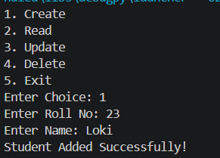
Read:
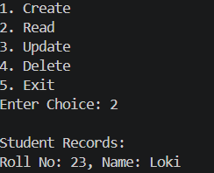

Update:
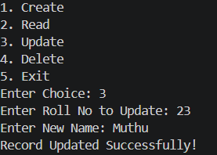
Delete:
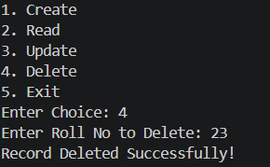
Exit:
